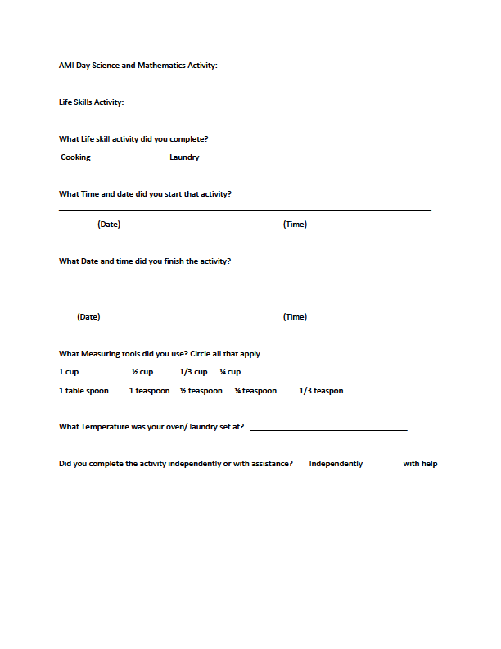

AMI Reading and English Assignment:
Pick a book, magazine, and or newspaper and read for 20 minutes.
What time did you start reading? __________________________
What time did you end? _________________________________
Title of what you read: ______________________________________________________________
The Author of what you read: ________________________________________________________
The page numbers that you read: __________________________________
Draw a picture of something that stood out in what you read below:

AMI Social Studies Assignment:
Write your complete name on the line provided:
_____________________________________________________________________________________
Write your home address:
_____________________________________________________________________________________
_____________________________________________________________________________________
____________________________________________________________________________________
____________________________________________________________________________________

Transitions:

Watch a movie pertaining to a specific career field.
What was the career/ job? _________________________________________________
What was the name of the movie? ___________________________________________
Is this a career you would be interested in? ____ Yes _____ No

